

**HOTEL MANAGEMENT SYSTEM**



**PROBLEM**

"Tree Hotel Manager" is a streamlined hotel management system implementing a binary tree structure for efficient room record management. This system allows users to seamlessly insert, search, update, and delete room records. The use of a binary tree ensures quick access and organized display of room records. Additional features include sorting records by Room ID and searching by Customer Name or Allocated Date, making it a powerful and user-friendly tool for hotel administrators.**Top of Form**

**CODE**

#include <iostream>

#include <fstream>

#include <conio.h>

using namespace std;

class TreeNode

{

public:

int id, date;

string name, roomtype;

TreeNode *left, *right;

TreeNode() : left(NULL), right(NULL)

{ }

};

class Hotel

{

public:

TreeNode *root;

Hotel() : root(NULL)

{ };

void insert();

void menu();

void update();

void search();

void Delete();

void show();

void searchByName();

void searchByDate();

private:

TreeNode* insert(TreeNode* root, int id, const string& name, int date, const string& roomtype);

void inOrderTraversal(TreeNode* root);

TreeNode* search(TreeNode* root, int id);

TreeNode* deleteNode(TreeNode* root, int id);

TreeNode* findMin(TreeNode* root);

TreeNode* updateNode(TreeNode* root, int id, const string& newName, int newDate, const string& newRoomType);

};

TreeNode* Hotel::insert(TreeNode* root, int id, const string& name, int date, const string& roomtype)

{

if (root == NULL)

{

TreeNode *temp = new TreeNode;

temp->id = id;

temp->name = name;

temp->date = date;

temp->roomtype = roomtype;

return temp;

}

if (id < root->id)

{

root->left = insert(root->left, id, name, date, roomtype);

}

else if (id > root->id)

{

root->right = insert(root->right, id, name, date, roomtype);

}

return root;

}

void Hotel::insert()

{

cout << "\n\t...............Hotel Management System................";

int id, date;

string name, roomtype;

cout << "\nEnter Room ID :" << endl;

cin >> id;

cout << "Enter Customer name :" << endl;

cin >> name;

cout << "Enter Allocated Date :" << endl;

cin >> date;

cout << "Enter Room Type(single/double/twin) :" << endl;

cin >> roomtype;

root = insert(root, id, name, date, roomtype);

cout << "\n\n\t\tNew Room Inserted";

getch();

}

TreeNode* Hotel::search(TreeNode* root, int id)

{

if (root == NULL || root->id == id)

{

return root;

}

if (id < root->id)

{

return search(root->left, id);

}

else

{

return search(root->right, id);

}

}

void Hotel::search()

{

cout << "\n\t...............Hotel Management System................";

int t_id;

if (root == NULL)

{

cout << "\n\nBinary tree is Empty";

}

else

{

cout << "\n\nRoom ID";

cin >> t_id;

TreeNode *result = search(root, t_id);

if (result != NULL)

{

cout << "\n\nRoom ID :" << result->id;

cout << "\n\nCustomer Name :" << result->name;

cout << "\n\nRoom Allocated Date :" << result->date;

cout << "\n\nRoom Type :" << result->roomtype;

}

else

{

cout << "\n\nRoom not found.";

}

}

getch();

}

TreeNode* Hotel::updateNode(TreeNode* root, int id, const string& newName, int newDate, const string& newRoomType)

{

if (root == NULL)

{

return root;

}

if (id < root->id)

{

root->left = updateNode(root->left, id, newName, newDate, newRoomType);

}

else if (id > root->id)

{

root->right = updateNode(root->right, id, newName, newDate, newRoomType);

}

else

{

root->name = newName;

root->date = newDate;

root->roomtype = newRoomType;

}

return root;

}

void Hotel::update()

{

cout << "\n\t...............Hotel Management System................";

int t_id;

if (root == NULL)

{

cout << "\n\nBinary tree is Empty";

}

else

{

cout << "\n\nRoom ID to Update";

cin >> t_id;

root = updateNode(root, t_id, "", 0, ""); // You may add prompts for new values if needed

cout << "\n\n\t\tUpdate Record Successfully";

}

getch();

}

TreeNode* Hotel::deleteNode(TreeNode* root, int id)

{

if (root == NULL)

{

return root;

}

if (id < root->id)

{

root->left = deleteNode(root->left, id);

}

else if (id > root->id)

{

root->right = deleteNode(root->right, id);

}

else

{

if (root->left == NULL)

{

TreeNode* temp = root->right;

delete root;

return temp;

}

else if (root->right == NULL)

{

TreeNode* temp = root->left;

delete root;

return temp;

}

TreeNode* temp = findMin(root->right);

root->id = temp->id;

root->right = deleteNode(root->right, temp->id);

}

return root;

}

TreeNode* Hotel::findMin(TreeNode* root)

{

while (root->left != NULL)

{

root = root->left;

}

return root;

}

void Hotel::Delete()

{

cout << "\n\t...............Hotel Management System................";

int t_id;

if (root == NULL)

{

cout << "\n\nBinary tree is Empty";

}

else

{

cout << "\n\nRoom ID";

cin >> t_id;

root = deleteNode(root, t_id);

cout << "Delete Room Record Successfully\n";

}

getch();

}

void Hotel::inOrderTraversal(TreeNode* root)

{

if (root != NULL)

{

inOrderTraversal(root->left);

cout << "\n\nRoom ID: " << root->id;

cout << "\nCustomer Name: " << root->name;

cout << "\nRoom Allocated Date: " << root->date;

cout << "\nRoom Type: " << root->roomtype;

inOrderTraversal(root->right);

}

}

void Hotel::show()

{

if (root == NULL)

{

cout << "\n\nNo Records Found\n";

}

else

{

cout << "\n\nRoom Records:\n";

inOrderTraversal(root);

}

getch();

}

void Hotel::menu()

{

int choice;

do

{

cout << "\n\t...............Hotel Management System................";

cout << "\n1. Insert a new room";

cout << "\n2. Update a room";

cout << "\n3. Search for a room";

cout << "\n4. Delete a room";

cout << "\n5. Show all rooms";

cout << "\n6. Exit";

cout << "\nEnter your choice: ";

cin >> choice;

switch (choice)

{

case 1:

insert();

break;

case 2:

update();

break;

case 3:

search();

break;

case 4:

Delete();

break;

case 5:

show();

break;

case 6:

cout << "\nExiting the program";

break;

default:

cout << "\nInvalid choice, please try again";

}

} while (choice != 6);

}

int main()

{

Hotel h1;

h1.menu();

return 0;

}

**OUTPUT**

**Insert a Room**

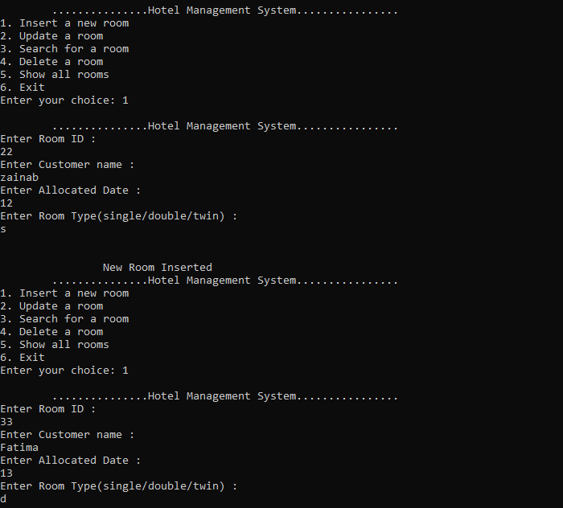

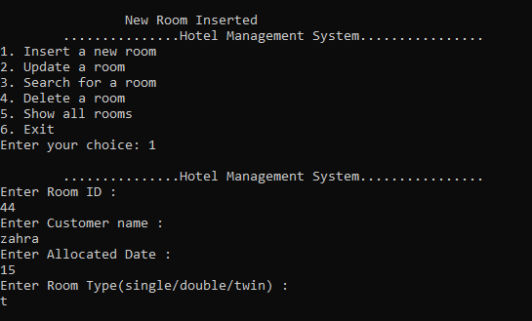

**Deleting 44 Room Id**

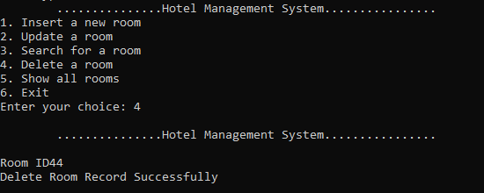

**Showing ROOM after deleting room id 44**

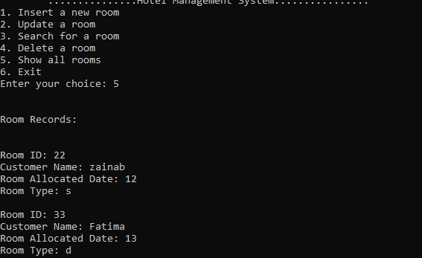

**Enter 6 to exit**

